Cheatsheet: List Comprehensions

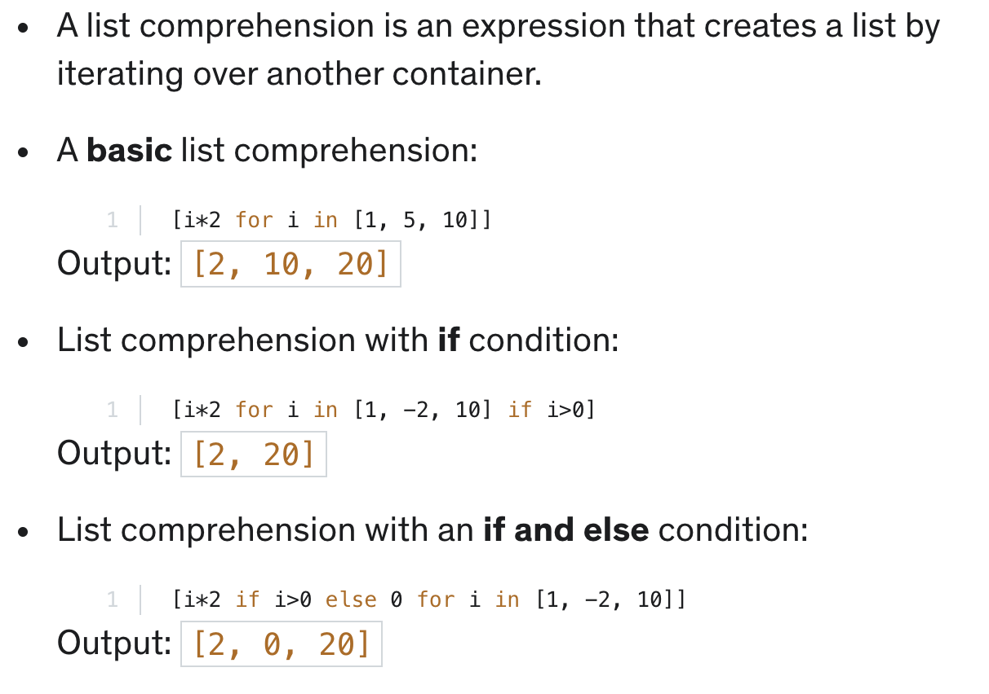
In this section, you learned that:

